An **electronic control unit** (**ECU**), also known as an **electronic control module** (**ECM**), is an [embedded system](https://en.m.wikipedia.org/wiki/Embedded_system) in [automotive electronics](https://en.m.wikipedia.org/wiki/Automotive_electronics) that controls one or more of the [electrical systems](https://en.m.wikipedia.org/wiki/Automotive_electronics#Types) or subsystems in a car or other [motor vehicle](https://en.m.wikipedia.org/wiki/Motor_vehicle).

Modern vehicles have many ECUs, and these can include some or all of the following: [engine control module](https://en.m.wikipedia.org/wiki/Engine_control_unit) (ECM), [powertrain control module](https://en.m.wikipedia.org/wiki/Powertrain_control_module) (PCM), transmission control module (TCM), brake control module (BCM or EBCM), central control module (CCM), central timing module (CTM), general electronic module (GEM), [body control module](https://en.m.wikipedia.org/wiki/Body_control_module) (BCM), and suspension control module (SCM). These ECUs together are sometimes referred to collectively as **the car's computer** though technically they are all separate computers, not a single one. Sometimes an assembly incorporates several individual control modules (a PCM often controls both the engine and the transmission).

Some modern motor vehicles have up to 150 ECUs. [Embedded software](https://en.m.wikipedia.org/wiki/Embedded_software) in ECUs continues to increase in line count, complexity, and sophistication. Managing the increasing complexity and number of ECUs in a vehicle has become a key challenge for [original equipment manufacturers](https://en.m.wikipedia.org/wiki/Original_equipment_manufacturer#Automotive_parts) (OEMs).

**DOOR CONTROL MODULE**

In [automotive electronics](https://en.wikipedia.org/wiki/Automotive_electronics), a door control unit (DCU) is a generic term for an [embedded system](https://en.wikipedia.org/wiki/Embedded_system) that controls a number of electrical systems associated with an advanced [motor vehicle](https://en.wikipedia.org/wiki/Motor_vehicle). A modern motor vehicle contains a number of ECUs ([electronic control units](https://en.wikipedia.org/wiki/Electronic_control_unit)), and the door control unit (DCU) is one of the minor ones.

The door control unit is responsible for controlling and monitoring various electronic accessories in a vehicle's door. Since most of the vehicles have more than one door, DCUs may be present in each door separately, or a single centralised one provided. A DCU associated with the driver's door has some additional functionalities. This additional features are the result of complex functions like locking, driver door switch pad, [child lock](https://en.wikipedia.org/wiki/Child_lock) switches, etc., which are associated with the driver's door. In most of the cases driver door module acts as a master and others act as slaves in communication protocols.

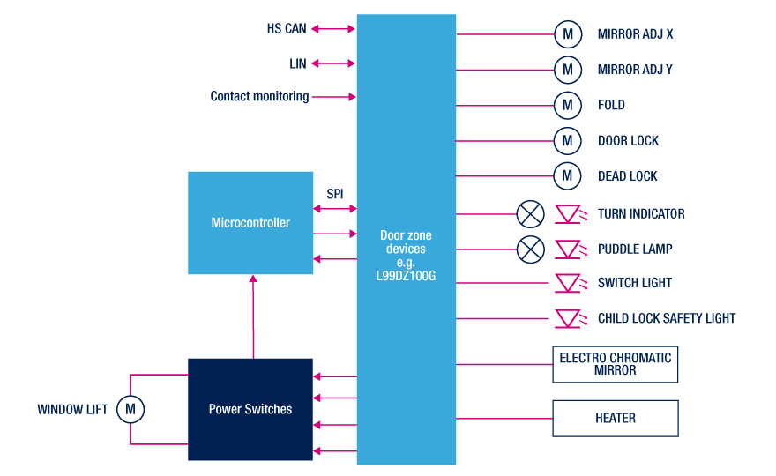

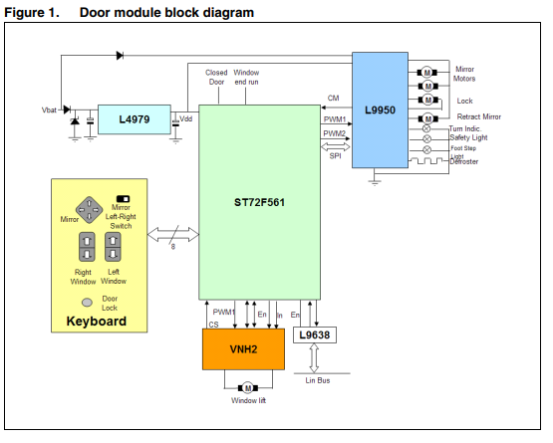

**Key elements**

* Core
  + [Microcontroller](https://en.m.wikipedia.org/wiki/Microcontroller)
* Memory
  + [SRAM](https://en.m.wikipedia.org/wiki/Static_random-access_memory)
  + [EEPROM](https://en.m.wikipedia.org/wiki/EEPROM)
  + [Flash](https://en.m.wikipedia.org/wiki/Flash_memory)
* Inputs
  + Supply Voltage and Ground
  + Digital inputs
  + Analog inputs
* Outputs
  + Actuator drivers (e.g. injectors, relays, valves)
  + [H bridge](https://en.m.wikipedia.org/wiki/H_bridge) drivers for servomotors
  + Logic outputs
* Communication links
  + Housing
  + Bus Transceivers, e.g. for K-Line, CAN, Ethernet
* Embedded Software
  + [Boot Loader](https://en.m.wikipedia.org/wiki/Boot_Loader)
  + Metadata for ECU and Software Identification, Version Management, Checksums
  + Functional Software Routines
  + Configuration Data